Avipsa Bal
25BAI10360
SmartHostel
Java Hostel Management System

Introduction
- SmartHostel is a Core Java based hostel management system designed to demonstrate how Java programming concepts can be combined into one practical college project.
- The application is intended for students, hostel administrators, and academic demonstrations where common hostel operations need to be organized digitally.
- It provides basic management of students, rooms, payments, and complaints through a structured Java application.
- The project focuses on Core Java concepts such as classes and objects, inheritance, polymorphism, encapsulation, exception handling, collections, file handling, and multithreading.
- The system is designed as a lightweight academic application without Maven, MySQL, JDBC, or JPA dependencies.

Problem Statement
- Hostel-related information is often maintained using separate registers, spreadsheets, or manual records.
- Manual room allocation can make it difficult to keep track of available and occupied rooms.
- Payment records need to be organized so that invalid or incomplete payment information can be identified.
- Student complaints may be difficult to track when there is no structured complaint-processing system.
- There is a need for a simple academic hostel management system that demonstrates how Core Java can solve these common management tasks.
- The project also provides a practical way to apply Java syllabus concepts instead of implementing them only as isolated laboratory programs.

Functional Requirements
- Allow users to create and manage student and administrator records.
- Maintain hostel room information including room number, capacity, and occupancy status.
- Allocate available rooms to students and prevent allocation when no suitable room is available.
- Record hostel payment information and validate payment details.
- Register and process student complaints.
- Display appropriate messages when invalid operations or custom exceptions occur.
- Use Java collections such as ArrayList, Vector, Stack, and arrays where appropriate.
- Read and write selected hostel records using Core Java file I/O.
- Provide a simple Java application flow through the Main class.

Non-functional Requirements
- Lightweight execution with no external database server or third-party framework requirement.
- The project should run using a standard Java Development Kit.
- The code should be modular so individual classes can be understood and modified independently.
- The interface and program output should remain simple and readable for student users.
- Exceptions should be handled without abruptly terminating the application during normal invalid input cases.
- File operations should be handled safely so that hostel records can be stored and retrieved when required.
- The system should be easy to extend with additional hostel features in future versions.

System Architecture
- Main Layer: The Main class controls the application flow and connects the different modules.
- Model Layer: User, Student, Admin, Room, Payment, and Complaint classes represent the main hostel entities.
- Service Layer: RoomAllocator and ComplaintProcessor contain operations related to room allocation and complaint processing.
- Exception Layer: Custom exceptions such as RoomNotAvailableException and InvalidPaymentException handle domain-specific errors.
- Utility Layer: FileManager and HostelUtils provide file-handling and common helper operations.
- Core Java Layer: Collections, arrays, file I/O, inheritance, interfaces, abstract classes, enums, and multithreading are used to implement the system.
- The project intentionally avoids Maven, MySQL, JDBC, and JPA so that the implementation remains completely Core Java based.

Design Diagrams
High-level module flow:
SMART HOSTEL
│
┌──────────────┼──────────────┐
│ │ │
Student Admin Main
│ │ │
└──────────────┼──────────────┘
│
┌───────────┼───────────┐
│ │ │
Rooms Payments Complaints
│ │ │
RoomAllocator Validation ComplaintProcessor
│
FileManager
│
Text Files
Class relationship overview:
User → Student / Admin
Student → Room / Payment / Complaint
RoomAllocator → Room + Student
ComplaintProcessor → Complaint
FileManager → File-based records
Custom Exceptions → Invalid operations

Design Diagrams
Basic use-case view:
Student ───────► View/Manage Hostel Details
Student ───────► Request Room Allocation
Student ───────► Make/Record Payment
Student ───────► Register Complaint
Admin ─────────► Manage Students
Admin ─────────► Manage Rooms
Admin ─────────► Process Complaints
Admin ─────────► Check Payment Records
Data flow:
Input → Validation → Java Object/Collection → Processing → Output
│
└────► File I/O when persistence is required

Design Decisions & Rationale
- Core Java was selected so the project directly demonstrates concepts taught in the Programming in Java syllabus.
- A modular class structure was chosen to keep hostel entities, business operations, utilities, and exceptions separate.
- Inheritance is used through the User base class and specialized Student and Admin classes.
- Encapsulation is used by keeping data members controlled through class methods.
- Method overloading and overriding are used to demonstrate compile-time and runtime polymorphism.
- Abstract classes and interfaces are included where common behavior needs to be defined separately from implementation.
- Custom exceptions make hostel-specific errors easier to identify and handle.
- Collections such as ArrayList, Vector, and Stack are used to demonstrate practical collection management.
- File I/O was selected instead of a database so the application remains completely Core Java and easy to run in a college environment.
- Multithreading and synchronized room allocation demonstrate safe handling of concurrent operations.

Implementation Details
- The project is organized into a Main class, model classes, service classes, exception classes, and utility classes.
- Model classes include User, Student, Admin, Room, Payment, and Complaint.
- RoomAllocator manages room-allocation operations and checks room availability before assignment.
- ComplaintProcessor manages the processing of registered complaints.
- RoomNotAvailableException is used when a requested room cannot be allocated.
- InvalidPaymentException is used when payment information fails the application's validation rules.
- FileManager implements Reader/Writer based file operations for storing and reading records.
- HostelUtils contains reusable helper operations used by the application.
- The implementation uses Java arrays and collection classes such as ArrayList, Vector, and Stack.
- The project also demonstrates nested/static classes, enums, interfaces, constructors, this/super, method overloading, method overriding, inheritance, polymorphism, and exception handling.
- No external database, Maven build system, JDBC, or JPA is required.

Screenshots / Results

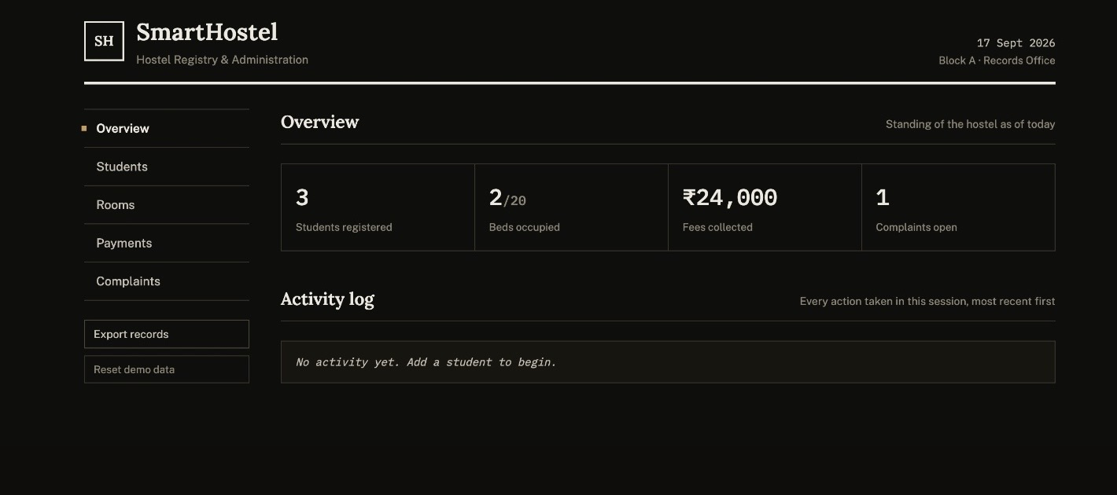

Testing Approach
- Manual user-flow testing was used to check the main hostel operations.
- Student creation and retrieval were tested with valid data.
- Room allocation was tested for both available and unavailable rooms.
- Payment processing was tested using valid and invalid payment values.
- Complaint registration and processing were checked using sample complaint records.
- Custom exceptions were tested to ensure invalid hostel operations produce controlled error messages.
- File read/write operations were tested to confirm that records can be stored and retrieved.
- Collection-based operations were checked to ensure student, room, payment, and complaint data are handled correctly.
- Concurrent room-allocation logic was considered through synchronized operations to reduce conflicting allocations.

Challenges Faced
- Combining many Core Java syllabus concepts into one coherent project required careful class and package organization.
- Designing relationships between User, Student, Admin, Room, Payment, and Complaint classes required keeping responsibilities separate.
- Room allocation needed validation so that an occupied or unavailable room could not be assigned incorrectly.
- Custom exceptions had to be introduced without making the main program difficult to follow.
- File handling required careful Reader/Writer usage and error handling.
- Using different collection types while keeping the application understandable required selecting each collection for an appropriate purpose.
- Adding multithreading and synchronized room allocation increased the need to think about concurrent access to shared room data.
- Keeping the project fully Core Java meant avoiding database and external framework dependencies.

Learnings & Key Takeaways
- Understood how Core Java concepts can be combined into a practical management application.
- Improved understanding of object-oriented programming through classes, objects, inheritance, encapsulation, and polymorphism.
- Learned how constructors, this, super, overloading, and overriding work together in a larger project.
- Gained practical experience with interfaces, abstract classes, enums, nested/static classes, and packages.
- Improved exception-handling skills by creating domain-specific custom exceptions.
- Learned how Java collections can be used for managing application data.
- Gained hands-on experience with Reader/Writer based file handling.
- Understood why synchronization is important when multiple threads can access shared resources.
- Improved modular programming and debugging skills through a multi-class Java project.

Future Enhancements
- Add a graphical user interface using Java Swing for easier hostel administration.
- Add stronger file-based persistence and structured record formats.
- Introduce role-based login and authentication for students and administrators.
- Add hostel attendance and visitor-management modules.
- Add room-transfer and room-vacancy history.
- Add automated payment reminders and payment-status summaries.
- Add complaint priority, status tracking, and resolution history.
- Add reports for occupancy, payments, complaints, and student records.
- A database-backed version can be developed later if external database technologies are permitted.
- The project can be extended into a larger hostel-management application while keeping the existing modular design.

References
- Oracle Java Documentation — Core Java language and API concepts.
- Oracle Java Tutorials / Java Language Specification — classes, inheritance, interfaces, exceptions, collections, and multithreading.
- Java Collections Framework documentation — ArrayList, Vector, Stack, and related collection classes.
- Java I/O documentation — Reader, Writer, file handling, and stream concepts.
- Java Swing documentation — reference material for possible future GUI enhancement.
- Course material and Programming in Java laboratory concepts used to design the SmartHostel application.

